# **Name: Abdurrahman Qureshi**

# **Roll No: 242466**

Assignment No: 1

Aim: To implement TELNET AND FTP BETWEEN N SOURCES – N Sinks using NS2

PROGRAM For TELNET FTP

# Simulation parameters setup

set val(stop) 10.0 ;# time of simulation end

# Initialization

set ns [new Simulator]

# Open the NS trace file

set tracefile [open out.tr w]

$ns trace-all $tracefile

# Open the NAM trace file

set namfile [open out.nam w]

$ns namtrace-all $namfile

# Create nodes

set n0 [$ns node]

set n1 [$ns node]

set n2 [$ns node]

set n3 [$ns node]

set n4 [$ns node]

# Define links between nodes

$ns duplex-link $n0 $n4 100.0Mb 10ms DropTail

$ns queue-limit $n0 $n4 50

$ns duplex-link $n1 $n4 100.0Mb 10ms DropTail

$ns queue-limit $n1 $n4 50

$ns duplex-link $n2 $n4 100.0Mb 10ms DropTail

$ns queue-limit $n2 $n4 50

$ns duplex-link $n3 $n4 100.0Mb 10ms DropTail

$ns queue-limit $n3 $n4 50

$ns duplex-link $n3 $n0 100.0Mb 10ms DropTail

$ns queue-limit $n3 $n0 50

# Define TCP connection

set tcp0 [new Agent/TCP]

$ns attach-agent $n0 $tcp0

set sink1 [new Agent/TCPSink]

$ns attach-agent $n2 $sink1

$ns connect $tcp0 $sink1

# Define UDP connection

set udp1 [new Agent/UDP]

$ns attach-agent $n1 $udp1

set null3 [new Agent/Null]

$ns attach-agent $n3 $null3

$ns connect $udp1 $null3

$udp1 set packetSize_ 1500

# Setup FTP application over TCP

set ftp1 [new Application/FTP]

$ftp1 attach-agent $tcp0

$ns at 1.0 "$ftp1 start"

$ns at 10.0 "$ftp1 stop"

# Setup Telnet application over UDP

set telnet0 [new Application/Telnet]

$telnet0 set interval_ 0.001

$telnet0 attach-agent $udp1

$ns at 1.0 "$telnet0 start"

$ns at 10.0 "$telnet0 stop"

# Termination function

proc finish {} {

global ns tracefile namfile

$ns flush-trace

close $tracefile

close $namfile

exec nam out.nam &

exit 0

}

# Schedule simulation end

$ns at $val(stop) "finish"

$ns at $val(stop) "puts \"done\" ; $ns halt"

# Run simulation

$ns run

OUTPUT:

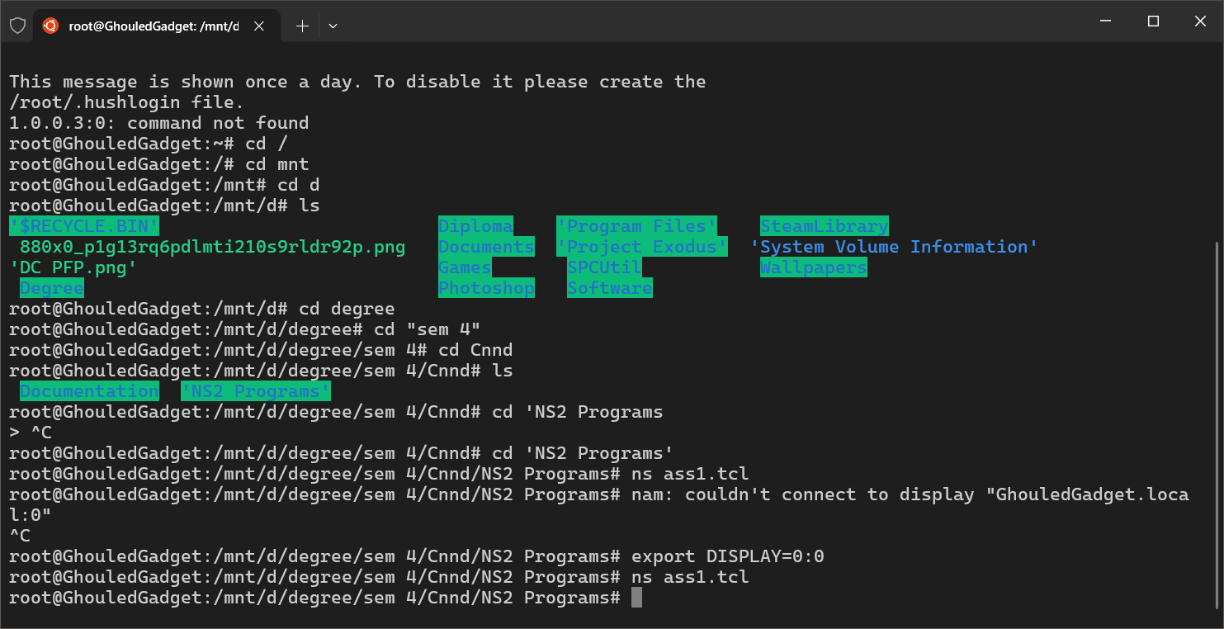

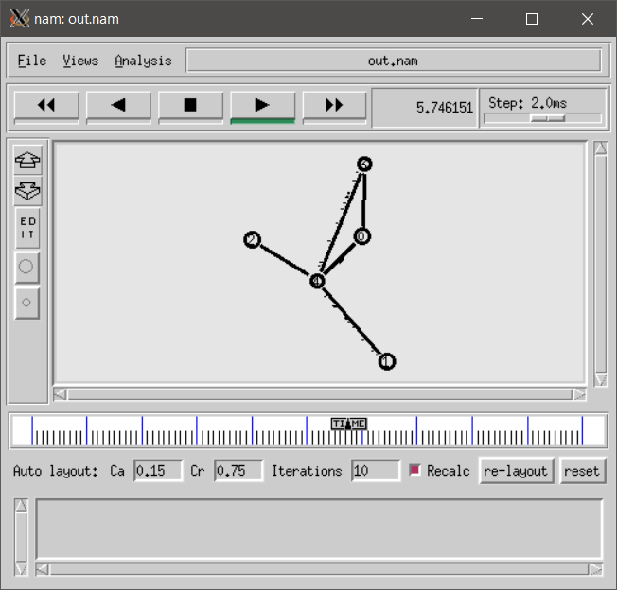 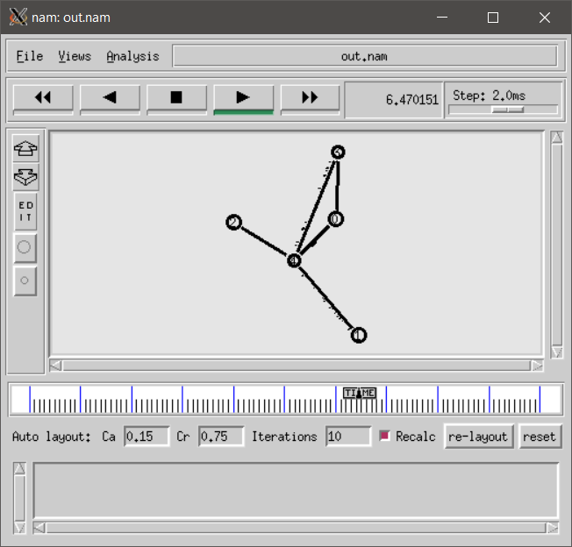

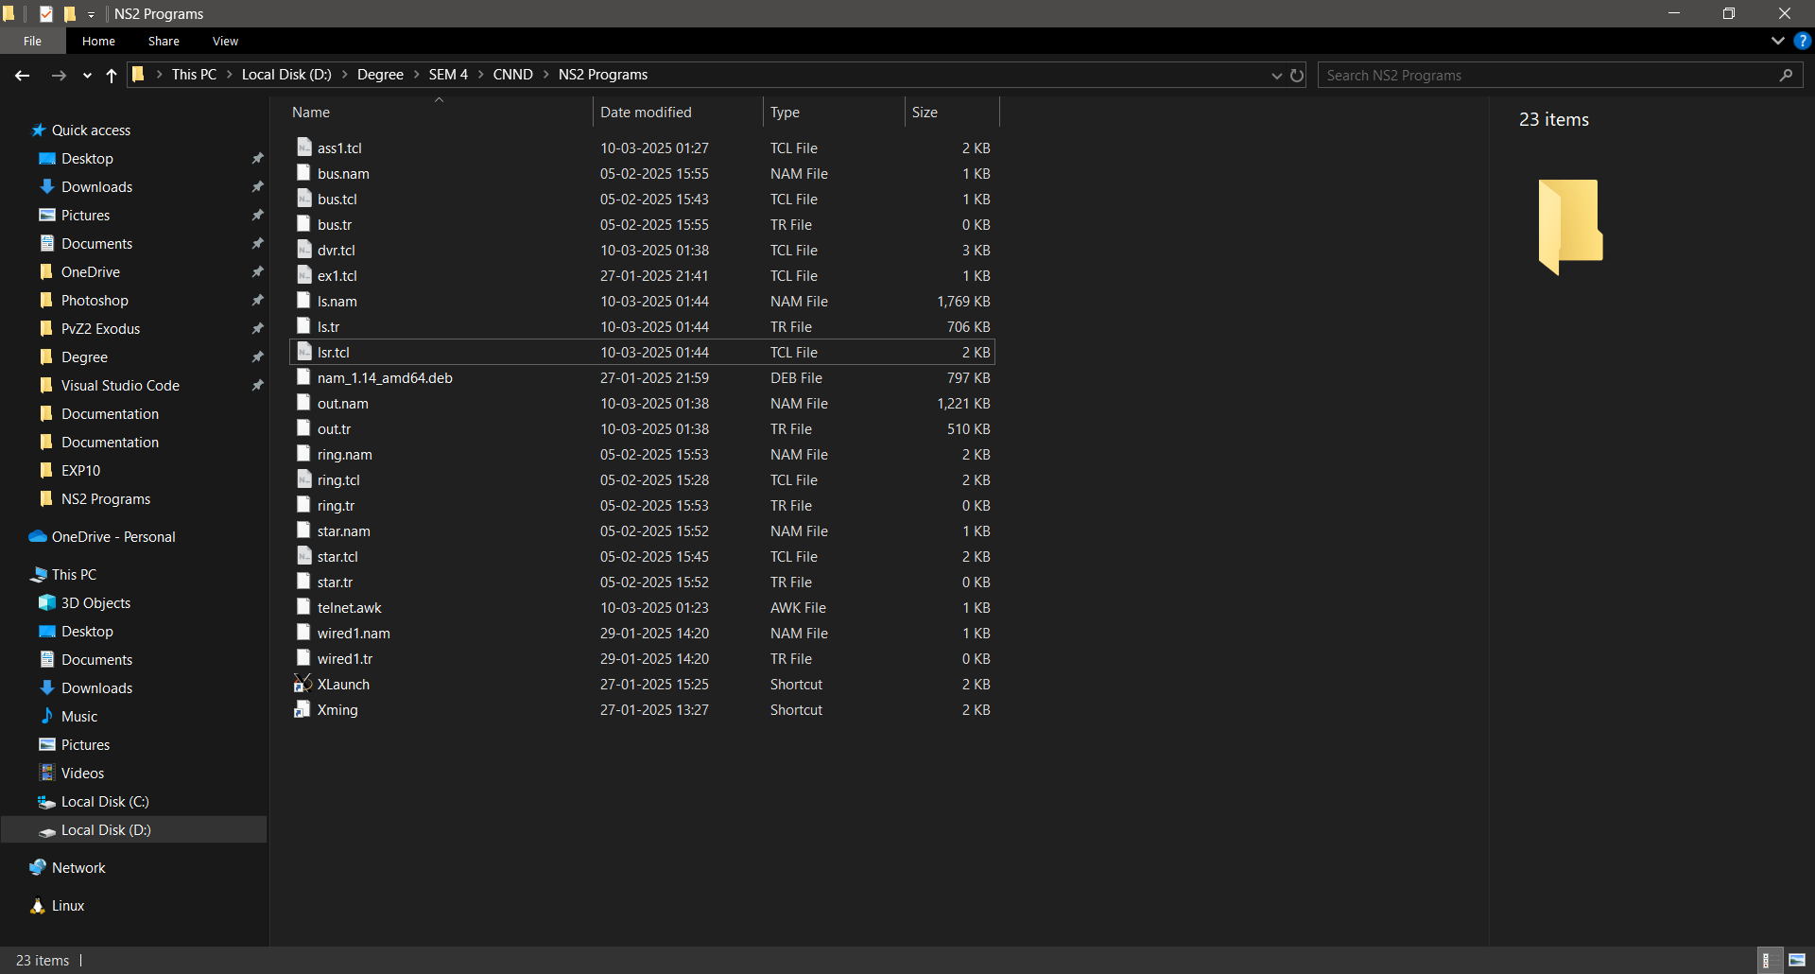

Program for Throughput of Telnet and FTP:

TCL Program:

#===================================

# Simulation parameters setup

#===================================

set val(stop) 10.0 ;# time of simulation end

#===================================

# Initialization

#===================================

#Create a ns simulator

set ns [new Simulator]

#Open the NS trace file

set tracefile [open out.tr w]

$ns trace-all $tracefile

#Open the NAM trace file

set namfile [open out.nam w]

$ns namtrace-all $namfile

#===================================

# Nodes Definition

#===================================

#Create 5 nodes

set n0 [$ns node]

set n1 [$ns node]

set n2 [$ns node]

set n3 [$ns node]

set n4 [$ns node]

#===================================

# Links Definition

#===================================

#Createlinks between nodes

$ns duplex-link $n0 $n4 100.0Mb 10ms DropTail

$ns queue-limit $n0 $n4 50

$ns duplex-link $n1 $n4 100.0Mb 10ms DropTail

$ns queue-limit $n1 $n4 50

$ns duplex-link $n2 $n4 100.0Mb 10ms DropTail

$ns queue-limit $n2 $n4 50

$ns duplex-link $n3 $n4 100.0Mb 10ms DropTail

$ns queue-limit $n3 $n4 50

$ns duplex-link $n3 $n0 100.0Mb 10ms DropTail

$ns queue-limit $n3 $n0 50

# Agents Definition

#===================================

#Setup a UDP connection

set tcp0 [new Agent/TCP]

$ns attach-agent $n0 $tcp0

set sink1 [new Agent/TCPSink]

$ns attach-agent $n2 $sink1

$ns connect $tcp0 $sink1

#Setup a UDP connection

set udp1 [new Agent/UDP]

$ns attach-agent $n1 $udp1

set null3 [new Agent/Null]

$ns attach-agent $n3 $null3

$ns connect $udp1 $null3

$udp1 set packetSize_ 1500

#===================================

# Applications Definition

#===================================

#Setup a FTP Application over TCP connection

set ftp1 [new Application/FTP]

$ftp1 attach-agent $tcp0

$ns at 1.0 "$ftp1 start"

$ns at 10.0 "$ftp1 stop"

#Setup a Telnet Application over UDP connection

set telnet0 [new Application/Telnet]

$telnet0 set interval_ 0.001

$telnet0 attach-agent $udp1

$ns at 1.0 "$telnet0 start"

$ns at 10.0 "$telnet0 stop"

#$ns at 10.0 "$cbr1 stop"

$telnet0 set type_ Telnet

#===================================

# Termination

#===================================

#Define a 'finish' procedure

proc finish {} {

global ns tracefile namfile

$ns flush-trace

close $tracefile

close $namfile

exec nam out.nam &

exit 0

}

$ns at $val(stop) "$ns nam-end-wireless $val(stop)"

$ns at $val(stop) "finish"

$ns at $val(stop) "puts \"done\" ; $ns halt"

$ns run

Telnet.awk Program:

BEGIN

{

    numTCP1=0;

    tcpSize1=0;

    numTCP2=0;

    tcpSize2=0;

    totaltcp1=0;

    totaltcp2=0;

}

{

    event=$1;

    pkttype= $5;

    fromnode=$9;

    tonode=$10;

    pktsize=$6;

    if(event == "r" &&pkttype == "udp" &&fromnode == "1.0" &&tonode == "3.0")

    {

        numTCP1++;

        tcpSize1 = pktsize;

    }

    if(event == "r" &&pkttype == "tcp" &&fromnode == "0.0" &&tonode == "2.0")

    {

        numTCP2++;

        tcpSize2 = pktsize;

    }

}

END {

    totaltcp1=numTCP1*tcpSize1*8;

    totaltcp2=numTCP2*tcpSize2*8;

    throughputtcp1= totaltcp1/24;

    throughputtcp2= totaltcp2/24;

    printf("The Throughput of FTP application is %d \n", throughputtcp1);

    printf("The Throughput of TELNET application is %d \n", throughputtcp2);

}

OUTPUT:

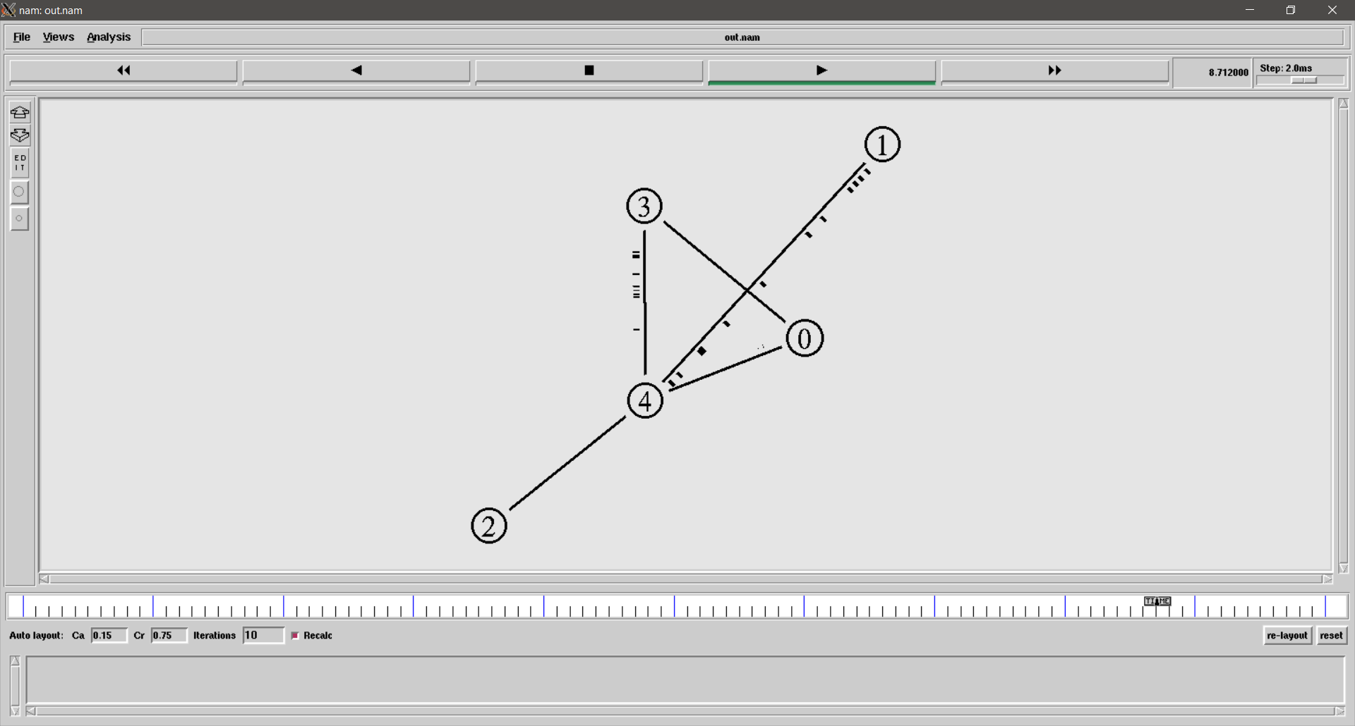

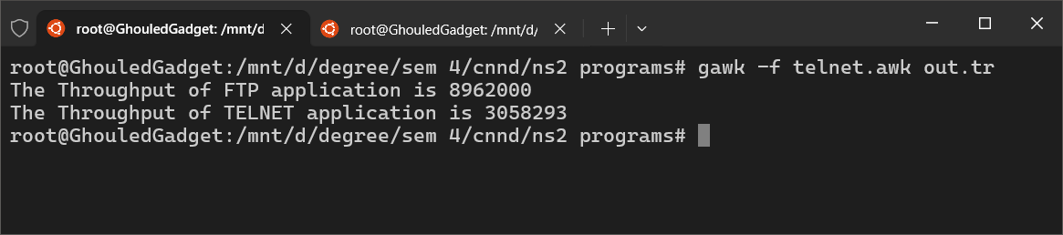

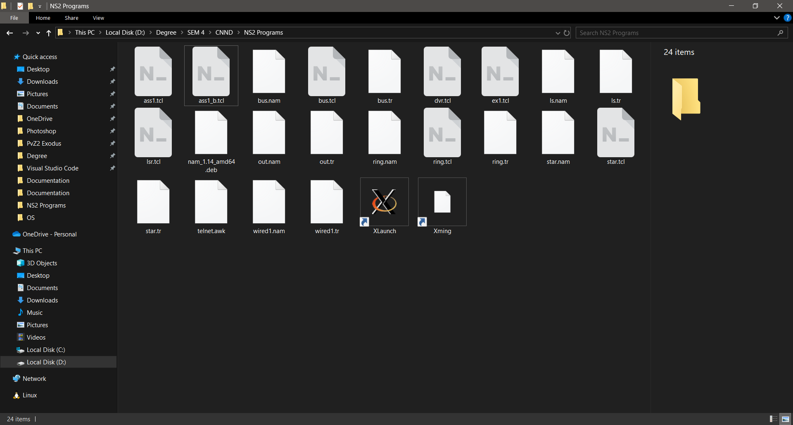

Conclusion:

In this assignment, we successfully simulated Telnet and FTP communication between multiple sources and sinks using NS2. The simulation involved configuring nodes, establishing TCP and UDP connections, and implementing Telnet and FTP applications over these connections. The generated trace and NAM files provided insights into packet transmissions. Furthermore, we used an AWK script to analyse the throughput of the Telnet and FTP applications.

The results showed the data transfer rates, confirming the efficiency of the communication model. This experiment demonstrates how NS2 can effectively simulate real-world networking scenarios, making it a valuable tool for research in network performance analysis.